MELESE LIGHT-ORR  COMMUNITY ORGANIZER • MUSICIAN • MENTOR • SCHOLAR-ATHLETE  Los Angeles, California • meleselightorr27@gmail.com  Class of 2027 • GPA: 3.9 unweighted / 4.4 weighted | 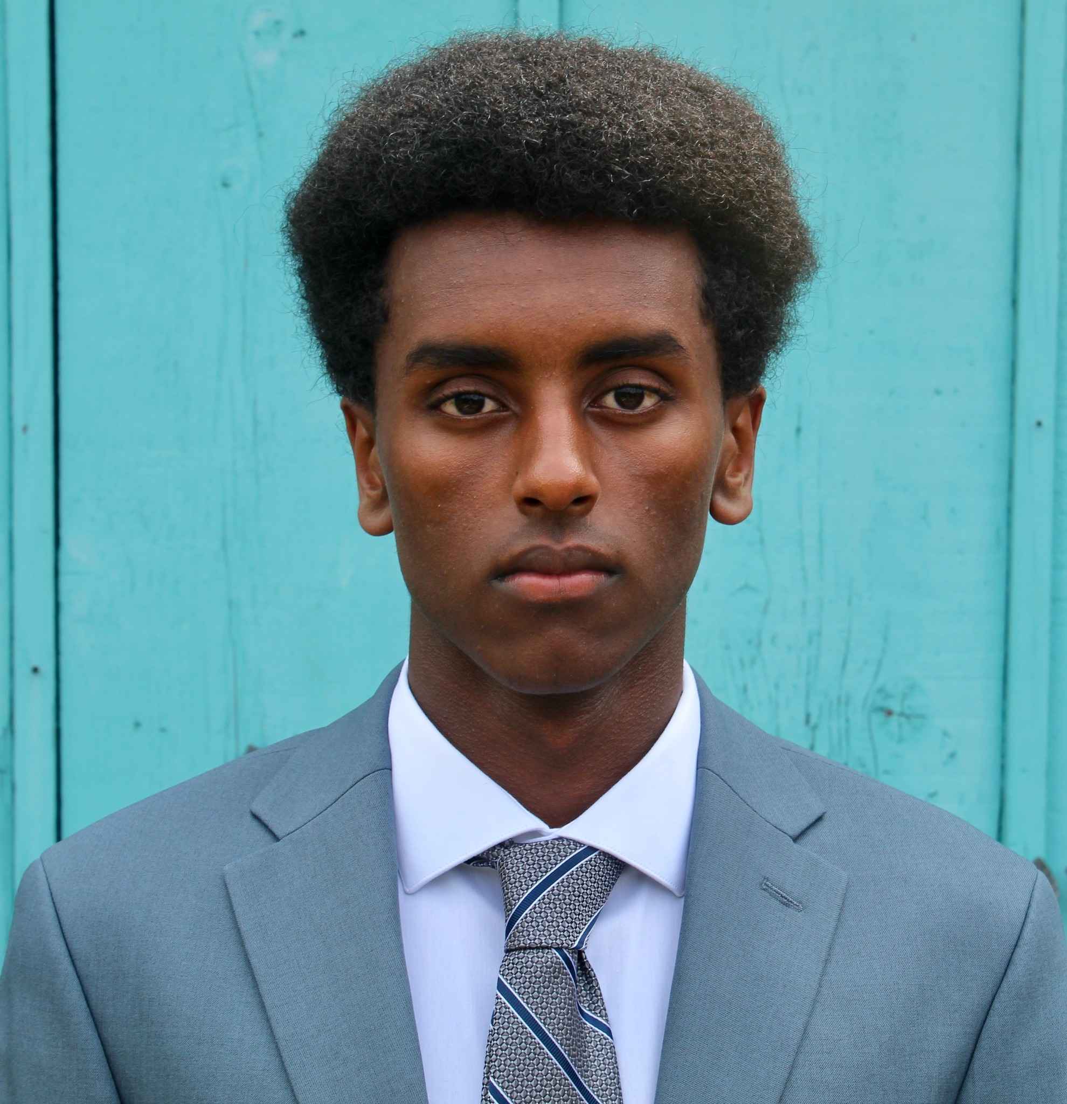

EDUCATION
Crossroads School for Arts & Sciences | Santa Monica, California | Class of 2027
- Academic interests: global affairs, public policy, political science, history, computer science, African and African Diaspora studies, Classics, and jazz performance.
- Arts Major: Jazz. Selected coursework includes Honors English, Honors Global Studies, Honors Latin, Honors Math, Honors Computer Science, Honors Chemistry, jazz theory, and advanced ensemble performance.

LEADERSHIP, CIVIC ENGAGEMENT & COMMUNITY IMPACT
Junior Ambassador & Youth Initiative Co-Founder, Tesfa Foundation | Elementary School–Present
- Represents an international nonprofit advancing education, healthcare, nutrition, and economic opportunity across rural Ethiopian school communities; presents to donors, civic groups, and nonprofit leaders.
- Co-founded Tesfa’s youth initiative in 2020; recruits volunteers, coordinates youth musicians, and supports campaigns connecting Los Angeles students with Kololo, his birth village.
Founder & President, Kids for Kololo Club | 2024–Present
- Built a 40+ member K–12 global service club mobilizing students, educators, families, musicians, local businesses, and community partners around education, nutrition, sustainability, and infrastructure.
- Leads Crossroads’ relationship with Kololo School, including student fundraising, cultural exchange, elementary-school presentations, and service-learning initiatives.
- Helped lead a student-driven project bringing first-ever electricity to Kololo School and approximately 30–40 nearby homes; transformer delivered and installation underway.
Founder & Executive Producer, Shine a Light Benefit Concert | 2025–Present
- Created and produces an annual youth-run, multi-band benefit concert for Kids for Kololo; secures venues, recruits performers, coordinates 50+ volunteers, develops community partnerships, and emcees the event.
- Produced concerts at The Crow in Santa Monica and a Brentwood estate, raising $38,000 across two years for school electrification and daily student nutrition.
Founder, Crossroads–Kololo Sister School Initiative | 2023–Present
- Created a schoolwide partnership linking Crossroads and Kololo School through classroom learning, service, cultural exchange, and the Sibling Gardens pepper-growing project.
Election Worker, Los Angeles County Elections | 2026
- Completed official training and worked more than 40 hours across a three-day primary election weekend, assisting voters and supporting polling operations.
Youth Leader, Teens for Karen Bass | 2023
- Canvassed, supported voter outreach, and helped organize a youth-led jazz fundraiser encouraging civic participation and youth engagement in local government.
Speaker, October Days Community Leadership Conference | 2025
- Sole student speaker alongside nonprofit executives, philanthropists, and community leaders; presented on youth leadership, educational equity, and community engagement.
Crossroads Representative, SLIDE (Student Leaders for Inclusion, Diversity, and Equity) | Harvard-Westlake & UCLA
- Chosen as one of two students to represent Crossroads; collaborated with student leaders on equity, belonging, and inclusive school practices.

SCHOOL LEADERSHIP, SERVICE & MENTORSHIP
Student Member, Equity & Justice Advisory Board | Crossroads Institute
- One of five students selected; helped lead an initiative expanding student access to college-counseling information and resources.
Selected Member, Community Service Leadership Board | Crossroads
- Helps shape and support student service efforts across the school community.
Workshop Developer & Presenter, Children’s Defense Fund Freedom School | 2024–Present
- Developed and presented four workshops for young scholars: one on activism, two on jazz, and one on robotics.
Math Tutor & Peer Mentor, Sister Circle | 2024–Present
- Recruited by faculty to tutor and mentor younger Black students in mathematics.
Additional involvement: BSU, Crossroads Ambassador, Pathways, Outdoor Education, and A Place Called Home.

MUSIC
Complete musician resume and performance reel available upon request. Jet Lag performance reel
Trumpeter, Fernando Pullum Community Arts Center Jazz Ensemble | 2026–Present
- Performs with the selective Leimert Park youth ensemble at regional festivals and cultural venues.
Co-Founder & Trumpeter, Jet Lag | Los Angeles • Shanghai • Rio de Janeiro
- Co-founded international contemporary-jazz ensemble; performed across Shanghai and Rio at JZ Club, Shanghai Tower, Beco das Garrafas, Audio Rebel, and CEFET/RJ; opened for New Jazz Underground.
Founder, Bandleader & Trumpeter, The Exit | Los Angeles
- Founded an Ethiopian jazz ensemble connecting traditional Ethiopian and contemporary American jazz; performed at The Industry Jazz Café.
Bassist & Trumpeter, Sunset Jazz Quartet / Jazzy Oneg | Los Angeles
- Performs at synagogues, senior communities, and community events, using jazz to foster cross-cultural and interfaith connection.
Trumpeter, Vanguard–Jazz 4 | Crossroads | 2026–27
- Selected for Crossroads’ premier audition-based performing ensemble.
Film Scoring Shadow, Composer Alex Heffes | The Bard | Evergreen Studios | 2026
- Observed Heffes compose and conduct a live orchestral scoring session to picture and followed collaboration among composer, musicians, and studio technicians.

SELECTIVE PRE-COLLEGE PROGRAMS
Carleton Liberal Arts Experience (CLAE) Scholar | 2026
- One of 28 students selected nationally; completed 30 hours of rigorous coursework, field experience, writing, discussion, and critical analysis.
Princeton AI4ALL | 2025
- One of approximately 30 students selected nationally for a three-week residential program exploring image classification, medical AI, ethics, and applications of computer science.
UCLA Global Jazz Summer Intensive Scholar | 2024
- Scholarship recipient for advanced jazz performance, ensemble study, and studio recording.

ATHLETICS & EMPLOYMENT
Varsity Swimming | Grades 9–12
- Member of the 2025 CIF Southern Section Division 3 championship team; raced freestyle in the 200-yard medley relay. Mentors younger teammates.
Lifeguard, Swim Instructor & Lifeguard Mentor | 2023–Present
- American Red Cross-certified Lifeguard and Water Safety Instructor; teaches swimmers ages 3–13, enforces safety standards, and mentors newer lifeguards.
Varsity Beach Volleyball | Grades 9–10
- Coach’s Award recipient.

HONORS, PRESS & INTERESTS
Honors: Gold Third Place, WorldStrides NYC Heritage Festival; Forum Festival; National Latin Award — Magna Cum Laude; National Mythology Award — Summa Cum Laude; four-time CAIS Honor Band selection (grades 8–11); Community Service Honors Society; Carleton CLAE Scholar; UCLA Global Jazz scholarship recipient.
Selected press: Santa Monica to Shanghai • Local Teens Leverage Santa Monica Community for a Global Impact
Interests: Public policy, educational equity, global development, jazz, technology, Latin, and beekeeping.

