MELESE LIGHT-ORR | TRUMPETER / JAZZ MUSICIAN / BANDLEADER / PRODUCER  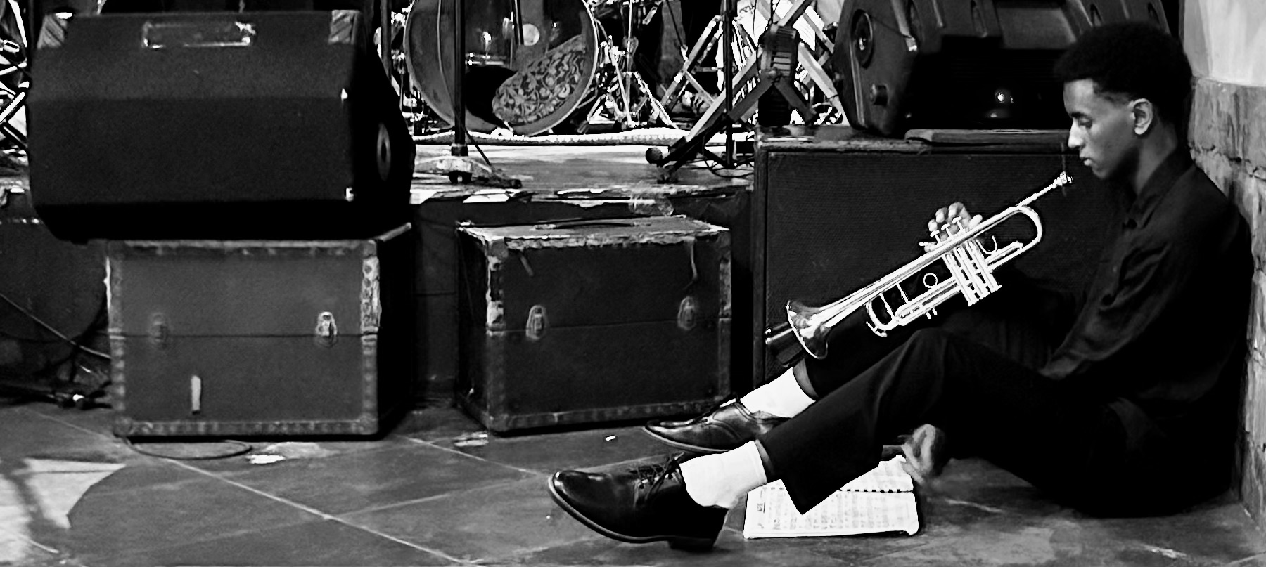  Los Angeles trumpeter, bandleader, and producer who founded Shine a Light, an annual multi-band concert that raised $38,000 across two years for Kids for Kololo. Performs jazz across the United States and internationally as co-founder of Jet Lag and founder of Ethiopian jazz ensemble The Exit.
  EMAIL  meleselightorr27@gmail.com | LOCATION  Los Angeles | PERFORMANCE REEL  YouTube: @jetlagband25
  SELECTED PROFESSIONAL PERFORMANCES  GARDENA JAZZ FESTIVAL | Fernando Pullum • August 2026  • 23rd annual festival, which draws 7,000+ attendees in recent years.  LEIMERT PARK JAZZ FESTIVAL | Fernando Pullum • August 2026  • 7th annual festival, Baldwin Hills Crenshaw Plaza.  VISION THEATRE GRAND REOPENING | Fernando Pullum • August 2026  • Performance celebrating the reopening of Leimert Park’s historic theater.  BOTTLE’S BAR AT BECO DAS GARRAFAS | Jet Lag • Rio de Janeiro • July 2026  AUDIO REBEL | Jet Lag • Rio de Janeiro • July 2026  CEFET/RJ ARTS PROGRAM | Jet Lag • Rio de Janeiro • July 2026  • Performed and mentored student musicians.  CATALINA BAR & GRILL | Vanguard–Jazz 4 • Hollywood  THE INDUSTRY JAZZ CAFÉ | The Exit • Los Angeles  JZ CLUB • CHAIR CLUB • SHANGHAI TOWER | Jet Lag • Shanghai  • Opened for New Jazz Underground and performed with vocalist Jasmine Chen.  ENSEMBLES & PROJECTS  JET LAG — Co-Founder & Trumpeter | Los Angeles • Shanghai • Rio  • Performs contemporary jazz and original arrangements internationally.  THE EXIT — Founder, Bandleader & Trumpeter | Los Angeles  • Leads Ethiopian jazz ensemble connecting Ethiopian and American jazz traditions.  VANGUARD–JAZZ 4 — Trumpeter | Crossroads  • Crossroads’ premier performing ensemble in the jazz program.  SELECTED PRESS  Santa Monica to Shanghai — Santa Monica Daily Press  Local Teens Leverage Santa Monica Community for a Global Impact — Santa Monica Daily Press  PROFESSIONAL REFERENCES  Luciana Souza • Ramsey Castaneda • Stephen Billington • Fernando Pullum • Shea Welsh | MUSIC LEADERSHIP  Shine a Light  Founder, producer, performer, and emcee of annual multi-band concert benefiting Kids for Kololo; raised $38,000 across two concerts.  TRAINING  Crossroads School for Arts & Sciences  Arts Major: Jazz • Class of 2027  Primary: Trumpet  Secondary: Bass  Study: Jazz performance, improvisation, theory, ensemble playing, arranging  Current private trumpet instructor: Massimo Paparello  HONORS  WorldStrides Heritage Festival  Forum Festival  CAIS Honor Band  UCLA Global Jazz Intensive Scholarship  FILM SCORING  THE BARD — Film Scoring Shadow with Alex Heffes  Shadowed BAFTA-winning composer Alex Heffes during a live orchestral scoring session at Evergreen Studios; observed composition, conducting, synchronization, and recording music to picture.  MUSICAL SKILLS  Trumpet • Jazz improvisation • Ensemble performance • Bandleading • Concert production • Bass • Music theory

